Name: Moses Muamba-Nzambi
Course: CST-250
Assignment: Activity 4
Date: Feb 22, 2026
Instructor: Mohammad Abu Matar

Github Link - https://github.com/MosesMNZ/CST-250-Activity4

Activity 4

Part 1

Below is the program being run after designing the UI

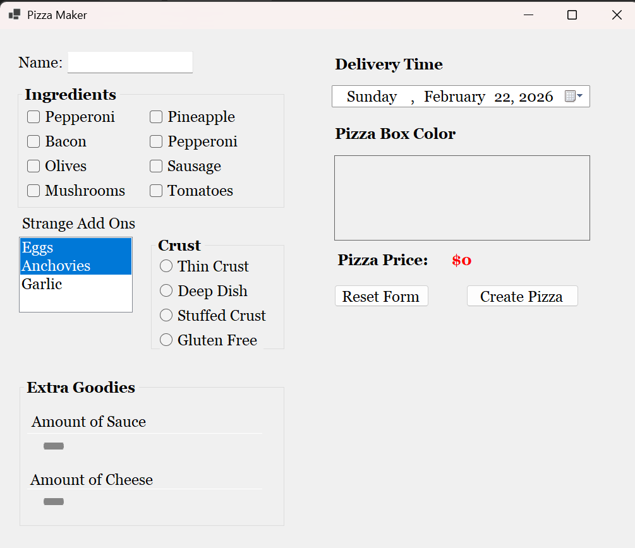

Part 2

Running the program with default values
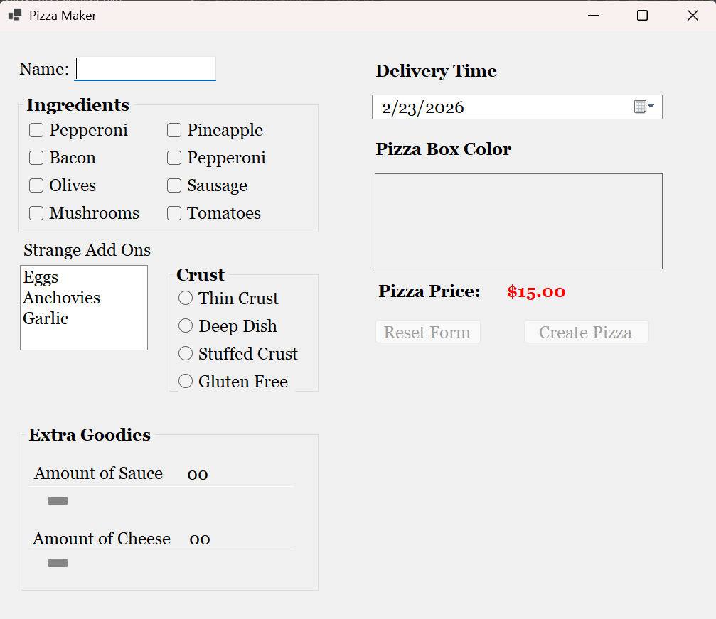

After customizing the pizza
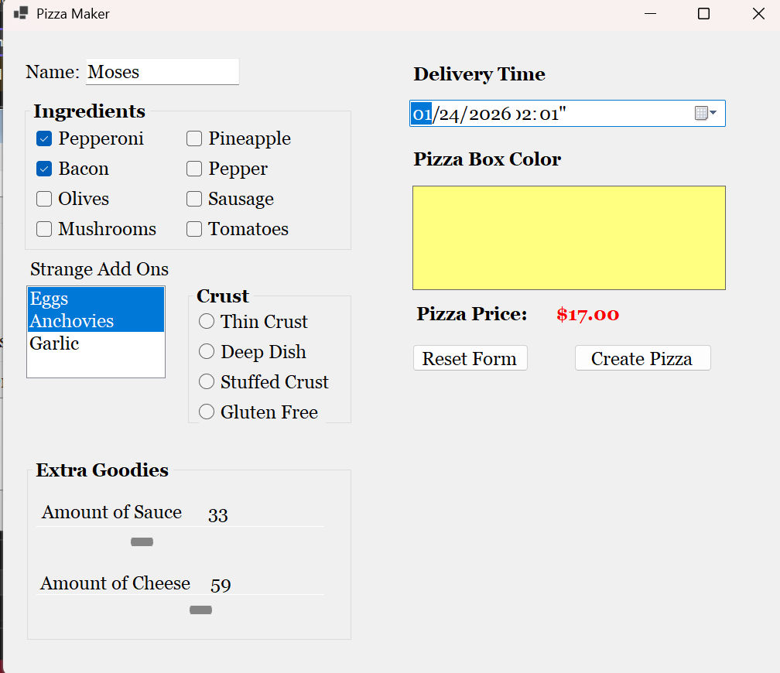

- A screenshot of the citations for PizzaModel and FrmPizzaMaker

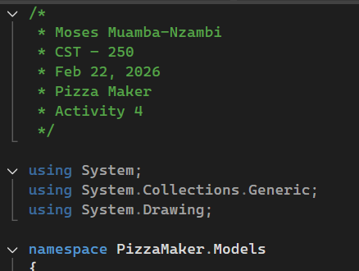

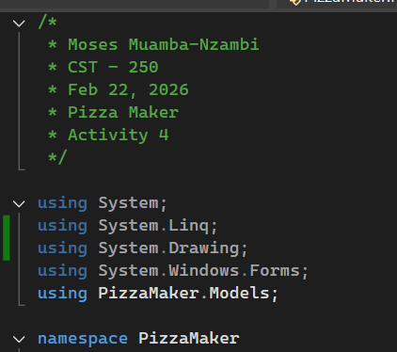

- A screenshot of the default constructors for PizzaModel and FrmPizzaMaker.

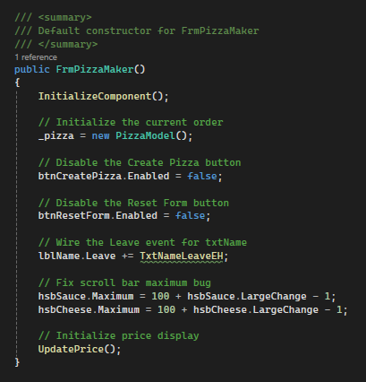

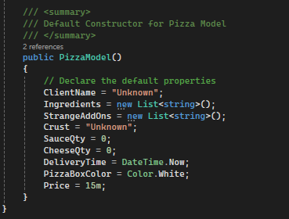

- A screenshot of the EnablePizzaCreation, TxtNameLeaveEH, UpdatePrice, ChbIngredientCheckedChangedEH, LsbStrangeAddOnsSelectedIndexChangedEH, RdoCrustCheckedChangedEH, HsbExtraGoodiesValueChangedEH, DtpDeliveryTimeValueChangedEH, PicPizzaBoxColorClickEH, BtnResetFormClickEH, ResetForm, and ResetControls methods in FrmPizzaMaker.

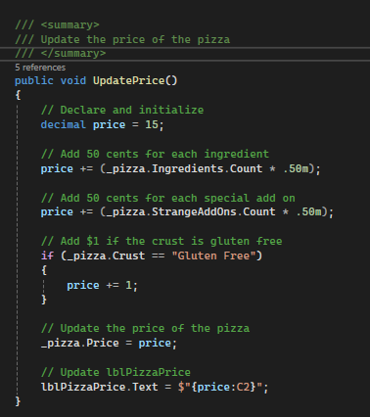

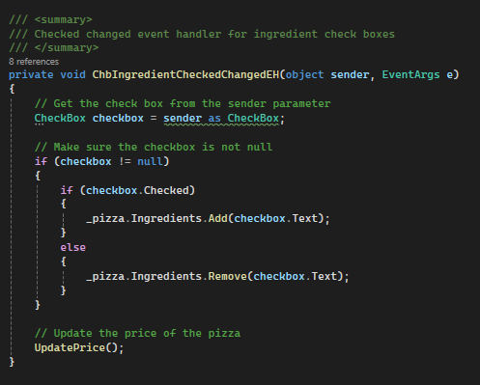

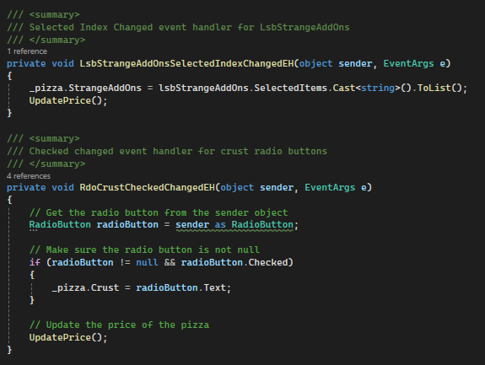
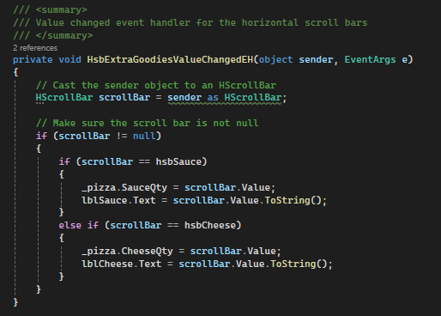

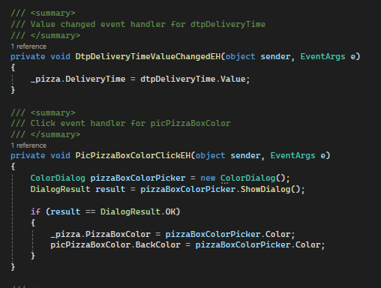

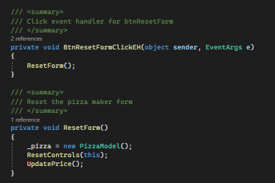

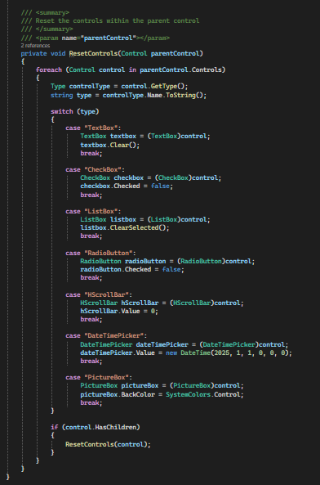
Part 3

- A screenshot of the FrmOrderDetails form running at this point with two orders.
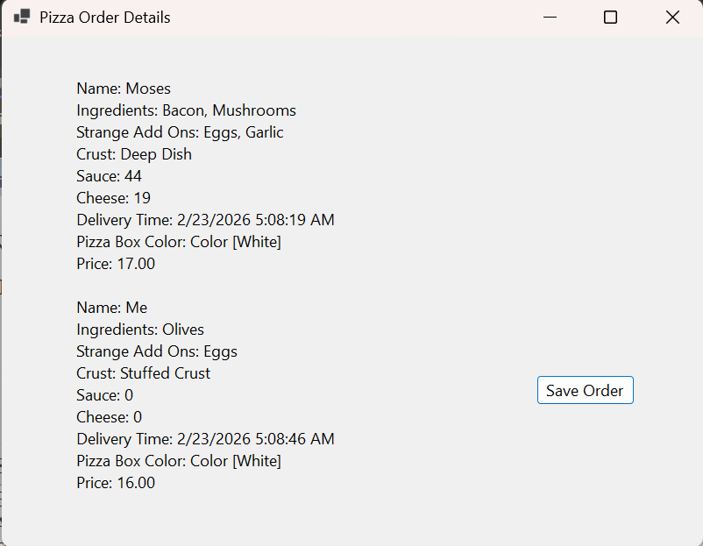

- A screenshot of the success message box.

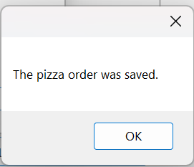

- A screenshot of PizzaOrder.txt with the saved orders.

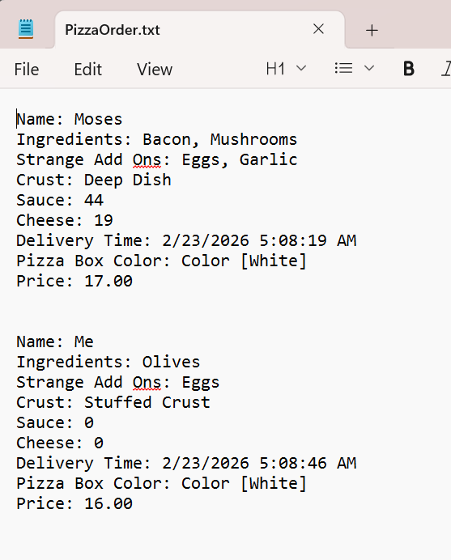

- A screenshot of the default constructor for FrmOrderDetails.

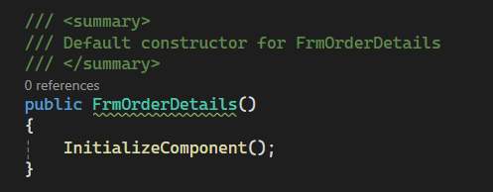

- A screenshot of the DisplayPizzas and BtnSaveOrderClickEH methods in FrmOrderDetails.

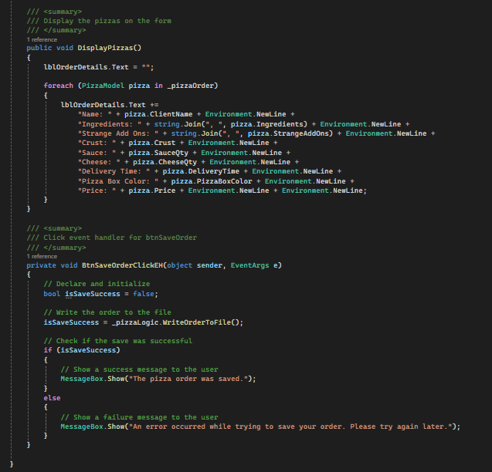

- A screenshot of the BtnCreatePizzaClickEH, and BtnSeeFullOrderClickEH methods in FrmPizzaMaker.

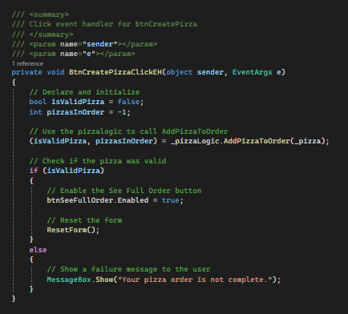

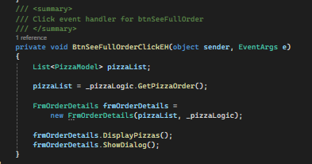

- A screenshot of the AddPizzaToOrder, GetPizzaOrder, and WriteOrderToFile methods in the PizzaLogic and PizzaDAO classes.

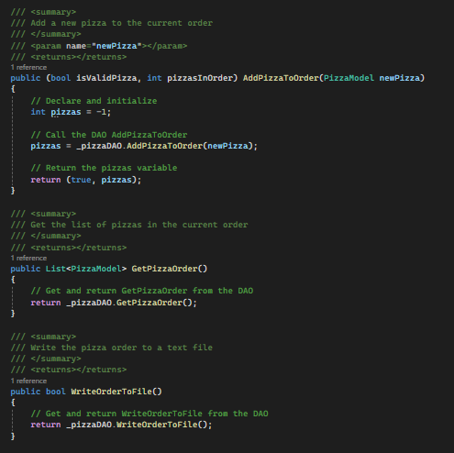

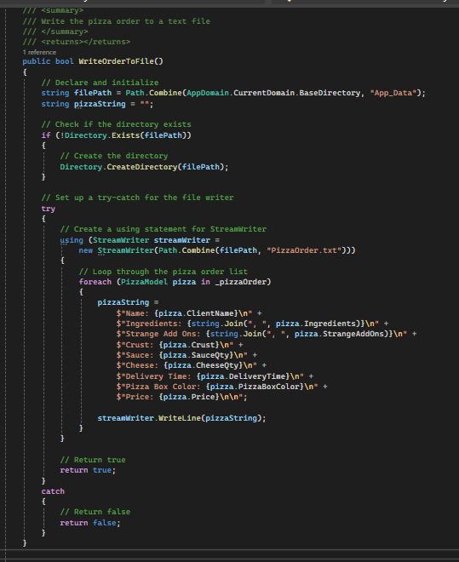
Challenge:

- Pizza Validation
After updating the AddPizzaToOrder method in PizzaLogic to make sure pizzas passed in are valid. A valid pizza has a name, a crust selection, at least one ingredient, and values greater than 0 for cheese and sauce.

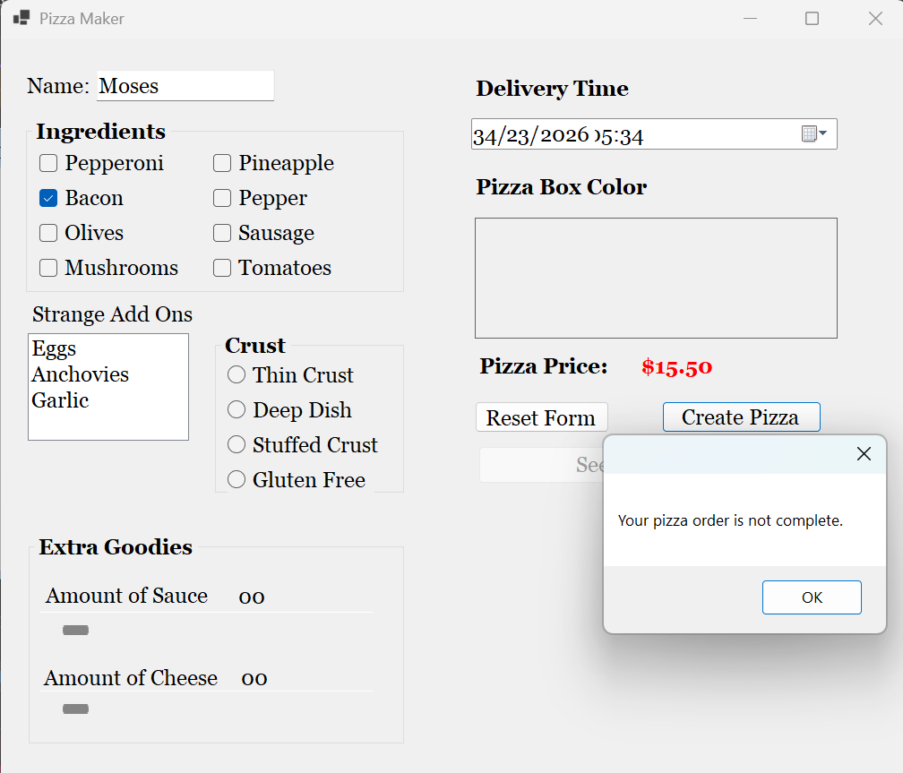

- Back Button
After adding a "Back" button to FrmOrderDetails so that the user can access FrmPizzaMaker to add more pizzas to his/her order.

The screenshot below was taken after adding 1 pizza

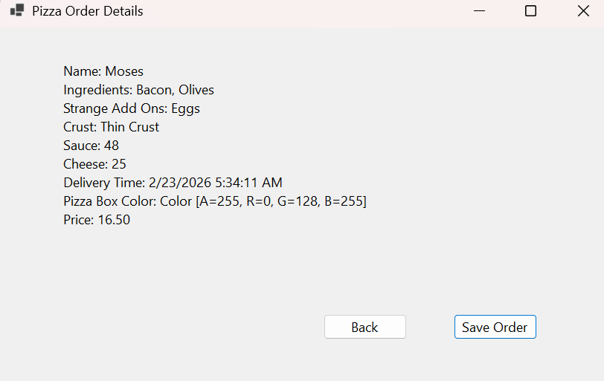

The screenshot below was taken after using the back button to create an additional pizza
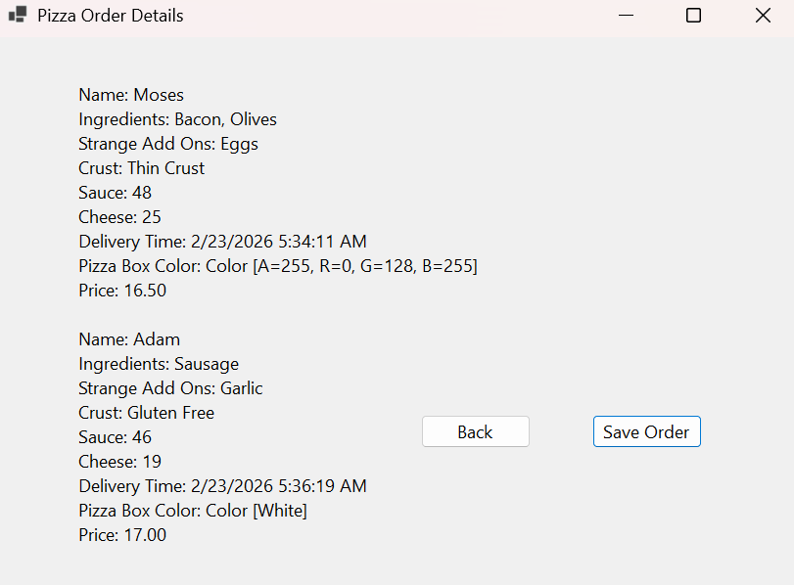

Below is the code to implement the above challenges

